RESTAURANT APPLICATION

Restaurant Application Project has been developed on Java Spring Boot. The Restaurant Application Project is an application which is based on managing the Food and sell Food online. The main objective of Restaurant Application is to provide all the details of Food and types of Food. There is a single role user i.e., Admin in this project who can manage all the Activity. Admin can manage Food, Food Type, and Bill. Only Admin can add, edit or delete the details of Food. Later at the process of finalizing the transaction, the information is accessed, and an order is generated against the selected item thus clearing the food cart.

Although the simplest food carts strictly allow for an item to be added to a basket to start a checkout process, most food cart software provides additional features that an Internet merchant uses to fully manage an online store. Data (types of food, categories, discounts, orders, customers, etc.) is normally stored in a database and accessed in real time by the software.

Contents

* Software and Hardware Requirements
* Class Diagram
* User Roles

1. Customer

2. Restaurant Manager

3. Admin

* Micro Services

1. Sign Up and Login

2. Booking Order

3. Menu

4. Contact

5. Payment

* Architectural Block Diagram
* Conclusion

Software Requirements:

|  |  |
| --- | --- |
| Language | Spring Boot |
| Database | Mongo DB |
| Software Development Kit | Java Jdk11 |
| API Client | Post Man |

Hardware Requirements:

|  |  |
| --- | --- |
| Processor | Intel i3 or Above |
| RAM | 4GB |

Use Case Diagram

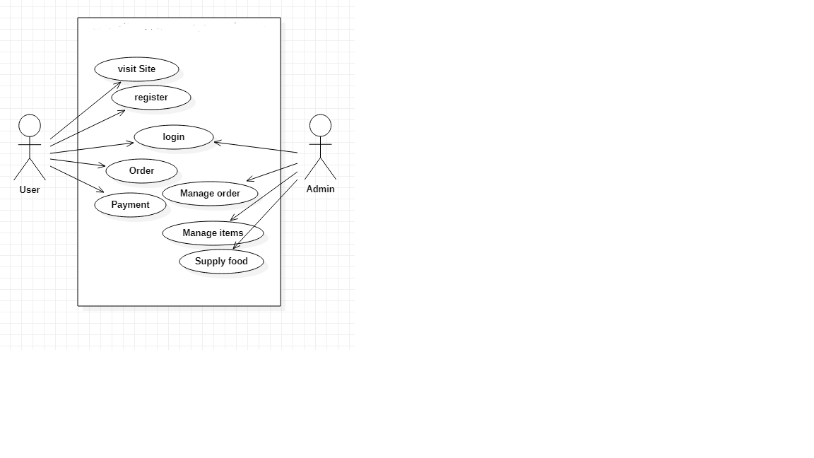

# **User Roles**

## **Customer**

We can see two types of customers in our system. Those are registered customer and unregistered user. We offer different services for those two customers in our system.

* 1. Registered user
     + Registered customer can view and buy food items through the web site.
     + They can manage their profiles and their user details
     + Users can use services such as adding food to the food cart and purchase cart for immediate or future purchases
     + User can use the ‘Chat app’ in order to communicate with the admin/store manager regarding any issues, it is our solution for customer service

* 1. Unregistered user
     + Unregistered users can only view products on the website
     + If they wish to access any more features they can sign up as a registered user

## **Restaurant Manager**

* Restaurant manager can add, update and delete new product details
* Restaurant manager also has access to add discount offers for products

## **Admin**

* Admin can administer the website; adding product categories
* Admin have the right to control the website processes such as order, delivery, track and payment etc., Admin can also change the settings if required.
* Payment Gateway:
* Admin Dashboard:

# **Micro Services**

## **Sign up and Login**

Unregistered users can use sign up page to register themselves. Then users who have registered can use the login page to login to the website.

## **Booking Order**

Restaurant app lets customer to view and order the Dish.

Registered users can rate and add comments to food products, they can also use the Chat App and other services provided by the application.

## **Menu**

It displays a list of dishes that may be ordered as in a restaurant or that to be served.

## **Payment**

This is the process following the food cart where user adds payment details and confirms their payment. The purchases can be viewed by the user.

## **Contact**

This Contact information provides the identity of and the means to communicate with restaurant.

## **Architectural Block Diagram**

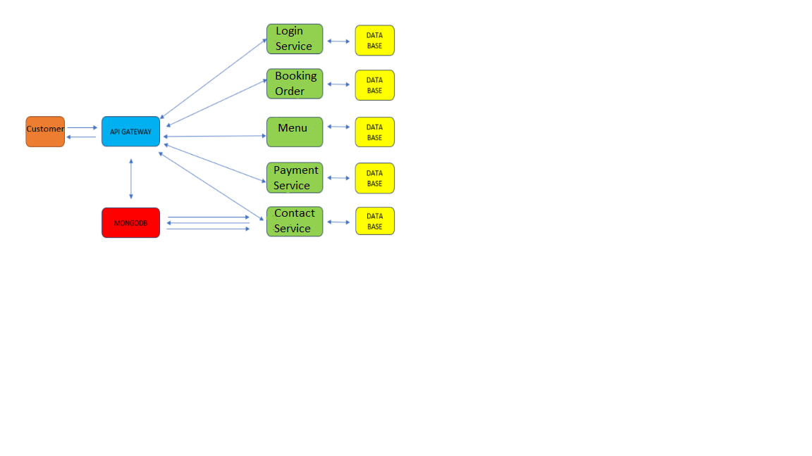

**Conclusion**

Considering the humongous sales projection, restaurant application development is becoming a key element for restaurant owners as it can result in improved sales and a high level of customer engagement.